Organic Chemistry

|  |  |  |  |  |  |
| --- | --- | --- | --- | --- | --- |
| Class of Compound | Structural Formula | Semi-Structural Formula | Suffix | Prefix | Polarity |
| Alkene | 8.1: Alkene Structure - Chemistry LibreTexts | -CHCH- | -ene |  | Slightly polar  - Weak Dipole-Dipole  -Dispersion |
| Haloalkane | Functional Groups in Organic Chemistry | -F -Cl  -Br  -I |  | -Fluoro  -Chloro  -Bromo  -Iodo | Polar  -H-Bonding only if another molecule has H-FON  -Dipole-Dipole  -Dispersion forces |
| Alcohol | Alcohol structure - Phenol structure- Hydroxyl Ether Structure ... | -OH | -(an)ol | Hydroxy- | Very Polar  -H-Bonding  -Dipole-Dipole  -Dispersion forces |
| Aldehyde | Aldehyde - Simple English Wikipedia, the free encyclopedia | -CHO | -(an)ane | Oxo- | Polar  -H-Bonding only if another molecule has H-FON  -Dipole-Dipole  -Dispersion |
| Ketone | Ketone - Wikipedia | -CO- | -(an)one | Oxo- | Polar  -H-Bonding if another molecule has H-FON  -Dipole-Dipole  -Dispersion |
| Carboxylic Acid |  | -COOH | -(an)oic acid |  | Very Polar  -H-Bonding  -Dipole-Dipole  -Dispersion |
| Ester |  | -COO- | -(an)oate |  | Very Polar  ~~-H-Bonding if another has H-FON~~  -Dipole-Dipole  -Dispersion |
| Amine | Primary Amine | OChemPal | -NH­2 | -amine | amino | -Very Polar  -H-Bonding  -Dipole-Dipole  -Dispersion |
| Amide | Structural Biochemistry/Organic Chemistry/Organic Functional Group ... | -CONH2 | -amide |  | Very Polar  -H-Bonding  -Dipole-Dipole  -Dispersion |

# Functional Groups

* As size of any molecule increases, dispersion forces become increasingly significant ⇒ interact primarily through dispersion ⇒ Soluble in non-polar molecules ⇒ Less soluble in Polar substances
* Side chains go in brackets:
  + Ex. methyl-propane: CH3CH(CH3)CH3
* Alphabetical order for functional group prefixes (Ethyl named and numbered before methyl)
* DON’T use di/tri prefixes for alphabetical ordering
* **Isomers have same molecular formula but different structural formula**

## Cycloalkanes (cyclo-R)

* General formula: CnH2n
* Ring structure with no double bonds
* Properties similar to alkanes
* Numbering of attached functional groups need to add up to lowest possible number

## Cycloalkene (cyclo-R-ene-R’)

* Same as cycloalkane but only one is hydrogen attached to carbons involved in double bond
* General formula: Cn­H2n-2x where x is number of double bonds
* Double bond needs to be between 1 and 2 in numbering (start at double bond)

## Alcohol (-OH)

* Alcohols can be described as primary, secondary or tertiary alcohols
  + Primary ⇒ -OH group at the end (bonded carbon only bonded to 1 other carbon atom)
  + Secondary ⇒ -OH group in middle (bonded carbon bonded to 2 other carbon atoms
  + Tertiary ⇒ -OH group in middle (bonded carbon bonded to 3 other carbon atoms)
* Primary and secondary alcohols can be oxidised to form other substance; tertiary alcohols cannot be oxidised:

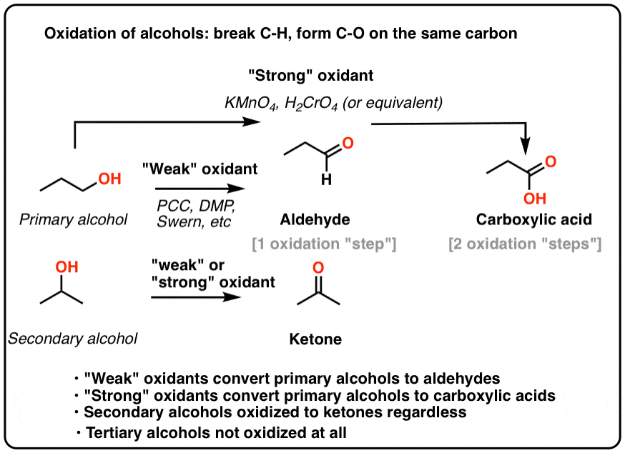

**Properties**

* BP of any alcohol is much higher than parent hydrocarbon ⇒ -OH capable of H-Bonding and dipole-dipole and increases mass, hence higher dispersion forces
* Soluble in any other substance capable of H-bonding or dipole-dipole forces ⇒ Solute-Solvent forces overcome constituent Solute-Solute and Solvent-Solvent forces
  + Completely miscible in H2O
* When 2+ functional groups are present, principal functional group is given priority (high to low):

1. Ester (-COO-)
2. Carboxylic acid (-COOH)
3. Amide (-CONH2)
4. Aldehyde (-CHO)
5. Ketone (-CO-)
6. Alcohol (-OH)
7. Amine (-NH2)
8. Aromatics
9. Alkene (-C=C-)
10. Alkyne (-C≡C-)

## Benzene

* C6H­6, flat hexagonal structure
* C-C bonds are identical, intermediate in length
* C bonds alternatively double bonded to neighbouring C atoms

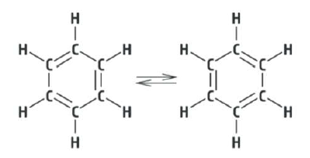

* Shorthand notations:

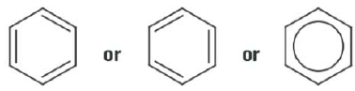

* **Aromatic** compounds are benzene based ⇒ H replaced with atoms or molecules
* **Carcinogen**

## Aldehyde (-CHO)

* Polar molecule but unable to bond through H-Bonding (lacks hydrogen atom bonded to FON)
  + Can bond with other molecules with H-FON with lone electron pair on O atom
* Higher BP than parent alkane but lower BP than alcohols of same size
* Soluble in compounds with molecules capable of dipole-dipole interaction
* Carbonyl group: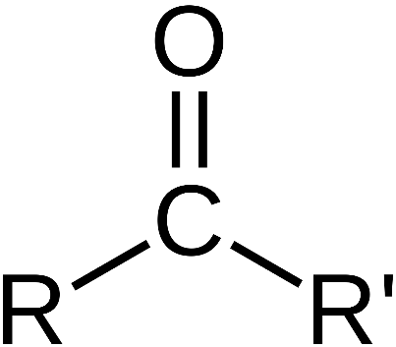

## Ketones (-ROR1-)

* Polar molecule and will interact primarily through dipole-dipole interactions
* Similar BP to Aldehyde of same mass
* Product of 2nd degree alcohol oxidation

## Carboxylic Acid (-COOH)

* Short chain carboxylic acids have a **pungent vinegary odour**
* Contains -COOH, the Carboxyl functional group (Carbonyl + Hydroxyl)
* Polar molecule and will interact primarily through H-Bonding
* BP much higher than any other hydrocarbon of similar molecule size
* BP slightly higher than corresponding main-chain alcohol
* Soluble in polar solvents, especially those with H-Bonds
* As length of carboxylic acid increases greater than hexanoic acid, substance becomes virtually immiscible
* Long carboxylic acid molecules are known as fatty acids
  + Soft, greasy feel
  + Insoluble in water
* Fatty acids occur in many living systems
* Carbon chain in plant fatty acids are unsaturated (contain alkene and alkyne functional groups) and double bonds form ***cis*** configuration
* Animal fatty acids are saturated (contain no alkene or alkyne functional group)
* Fatty acids are related to, but not the same as fats and oils
* In plants and animals, fatty acids are converted to triglycerides (fats and oils)
  + Fats and oils are important for energy storage

## Amines (-NH2)

* Polar and capable of H-Bonding ⇒ BPs higher than hydrocarbons but lower than alcohols of similar molecular size
* Weaker H-bonding of amine than alcohol occurs due to lower electronegativity of nitrogen (3.0) compared to oxygen (3.5) ⇒ weaker dipole and H-Bond
* Soluble in polar solvents, especially those with H-bonds

## Amides (-CONH2)

* Individual H-Bonding strength is greater than similar amines or carboxylic acids:
  + Greater number of suitable lone electron pairs and H atoms available for H-bonding in amide (2 H-atoms and 3 lone pairs) than similar amine or carboxylic acid
  + Close proximity of highly electronegative O atom causes H atoms from NH2 group to develop larger dipole than normal
* Therefore, BP of amides are higher than amines, alcohols, and carboxylic acid
* Soluble in other solvents which interact strongly through H-bonds

## Esters (-COO-)

* Ester group creates a degree of polarity at centre of ester molecule
  + Allows for dipole-dipole and dispersion interactions
  + H-Bonding?
* Therefore, BP is similar to aldehydes and ketones but lower than alcohols and carboxylic acids of similar molar mass
* **Pleasant fruity odours** for small molar mass esters
* High molar mass esters are **solid** with a **waxy feel**
* Lower molar mass esters are volatile
* Used as solvents
* Useful for adding fruity and floral odours in foods and cosmetics
* Leaves of most plants have protective wax coating of high molar mass esters
* Esterification:

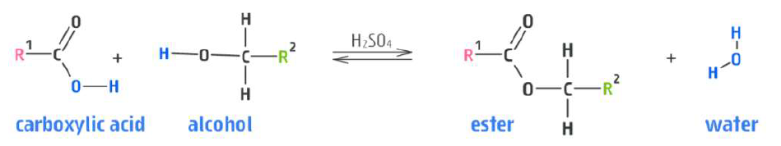

* Reverse reaction occurs when acid is added to ester
* Base added ⇒ Ethanoate Salt + alcohol

# Fats and Oils

* Triglycerides ⇒ fats and oils (type of ester)
* Triglycerides contain fatty acid molecules attached to a main ester group
* Vegetable oils are unsuitable for cooking because they remain a liquid when heated
  + Unsaturated fats from plants also tend to spoil quicker (due to more reactive double bounds, capable of addition reactions)
  + Hydrogenation is solution ⇒ converts unsaturated liquid vegetable oils into more versatile solid products (ex. shortening, margarine)
    - Addition reaction where H atoms add to some double bonds in triglyceride carbon chains
    - Reduces degree of unsaturation and produces solid fat
    - Hydrogenation can produce an undesirable side reaction which converts some cis double bonds in triglyceride carbon chain into trans form
      * Trans isomers are unsaturated but their linear geometry increases dispersion forces and allows molecules to pack more efficiently than cis form
        + Trans fats solidify more readily than cis ⇒ poses a risk to cardiovascular system

# IMFs

* Intermolecular forces ⇒ forces between molecules
* Dispersion forces ⇒ a temporary dipole that exists as a result of fluctuations in the electron cloud
  + Constantly moving electrons form a **temporary dipole**
  + **All** molecules with electrons exhibit dispersion forces
  + Packing density (**Steric Hinderance**) ⇒ Straight carbon chain molecules exhibit stronger dispersion forces (bent exhibit weaker)
* Dipole-dipole forces ⇒ permanent dipoles
  + Two requirements for molecules to exhibit dipole-dipole:
    - Have to be polar bonds
      * Bonds involving elements with differences in electronegativity
      * Non-symmetrical molecule
  + δ+⇒ positive dipole
  + δ+ ⇒ negative dipole
* Hydrogen-Bonding ⇒ Extreme dipole-dipole bond between very electronegative ion and hydrogen attached to very electronegative ion
  + H-FON (H bonded to F, O or N)
* Mention **SUM OF ALL IMFS** in answers
* Substitution reactions ⇒ one atom is swapped for another
* Addition reactions ⇒ double bond is broken, creating two reactive sites available for other atoms/molecules to bond
* Types:
  + Halogenation (+ Halogen – F2, Cl2 etc)
  + Hydrohalogenation (+ Hydrohalogen – HCl, HF etc)
  + Hydrogenation (+ Hydrogen – H2)
  + Hydration (+ Water – H2O)
    - Addition reaction with alkene creates an alcohol (H+ and OH- bonds separately)
* Long chain carboxylic acids ⇒
  + Plant fatty acid, unsaturated (oleic acid) in cis configuration
  + Animal fatty acid, saturated (stearic acid)

Model Answer (solubility)

* Detail cohesive forces in solute and how much solute-solute interactions resist mixing
* Detail cohesive forces in potential solvent and how much solvent-solvent interactions resist mixing
* Detail nature of any potential solute-solvent interactions and how much they assist mixing
* If it is soluble, solute-solvent interactions outweigh solute-solute and solvent-solvent forces

Mistakes

* **prefixes always in alphabetical order** ⇒ only suffixes require priorities

